FAQ’s for Mileage

1. How to correct a returned mileage claim?
A. Go back into your Employee Portal click on:
Reimbursements, then
Mileage
B. Go to Claim date and click on the one that has the status Returned.
C. Open mileage claim, make corrections and submit.

2. What is a round trip?
A round trip is when you start at point A then you travel to point B and then back to point A.
Example:
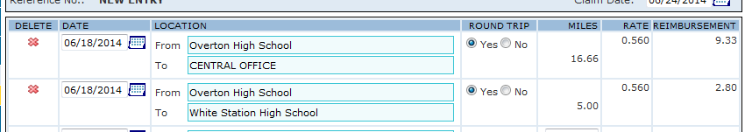
You start at Overton High School go to the Central Office and back to Overton High School. On the same day next line you would start back at Overton High School.

3. Why aren’t the miles calculating?
Always make sure you use the drop box boxes. If you find one that is calculating incorrectly or not at all, send me an e-mail.
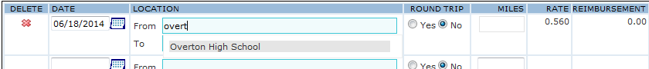
Click on the gray shaded drop down box.

4. Why was my mileage denied?
There is a calendar posted with Mileage Reimbursement Schedule, always make sure you have your mileage submitted on time. I suggest that you start your mileage the first week of each month and save, I’m not finished, that way you can always go back and update it weekly.

5. When I am in my Employee Portal and see the status New or Pending what does that mean?
The status New means that your supervisor/principal has not approved it yet. Pending means it is at the Central Office awaiting processing. Please allow 2 weeks after you submit your mileage for processing, there are a lot of mileage claims to review.
Mileage questions or concerns contact:
engramk@scsk12.org

